People of the Holocaust Database
Tania Mishra, Brigid Donaghy, Xavier Barth, Luu Tran

Business Plan
November 3, 2025

Section 1: Product and Customer Definition
Introduction to Product
The People of the Holocaust Database is a tool derived from The United States Holocaust Memorial Museum Encyclopedia of Camps and Ghettos, 1933-1945. Our tool will be a large database of people involved in some way with the Holocaust (both perpetrators and victims), along with certain attributes (locations, dates of interest, etc.). The tool will include a website through which users can query the database and visualize the path of an individual on a map.
Description of Problem
The Encyclopedia of Camps and Ghettos (referred to henceforth as ECG) is currently available in a physical book or online article format located on Project MUSE’s website. In its present form, Project MUSE’s accessibility features for the ECG leave ample room for improvement. Existing filters are arduous to traverse, and user searches provide arbitrary findings through pages just simply including the provided query. It itself is largely simplistic in accessing data, using a simple keyword search to find all instances of a certain name or keyword.
Primary Customer
Our primary customer for this software is mainly students and teachers who use this software to get information about locations and people involved in the Holocaust. Mainly, this software looks to provide information about the Holocaust to users of the software.
User Story
This software comprises a database containing information sorted to provide easier access to users wanting to access information from The United States Holocaust Memorial Museum Encyclopedia of Camps and Ghettos, 1933-1945. All the data has been organized, allowing users to search specific information about people and places involved in the Holocaust
Stakeholders
- Project MUSE, hosts the digital version of the ECG
- Bader Philanthropies, current funder of the project
- United States Holocaust Memorial Museum, creators of the ECG
Key Performance Indicators
Project MUSE
- Software must use accurate and vetted information from the ECG
- Software must be maintained with additional volumes of the ECG
Bader Foundation
- Software must provide a sorted database of the victims and perpetrators of the Holocaust
Teachers/Students
- Software must provide an accessible website to query and have map of people and locations for select time periods during the Holocaust
- Software must be easily integrated into courses focused on the Holocaust
Interoperability
Our project relies on the digital version of the ECG, which is hosted by Project Muse. Thus, we are reliant on Project Muse’s format of the ECG, and changes to their website could affect future updates to our software. However, our software is a standalone product, as it does not require continuous connection with the digital ECG; once the content of the ECG articles is loaded into our database, our project will not rely on outside software.
Uptime Requirements
Our software is largely dependent on our database, which will have to be maintained and updated along with additions to the ECG. Given that more volumes are yet to be published by the USHMM and then digitized by Project Muse, we expect that uptime will be working largely with the databases, as well as the algorithm used to sort the information. In addition, it will be important to maintain the security of the website so that sensitive data is not leaked or used for inappropriate purposes.

Section 2: Market Survey
Geographic Region
Our tool will be available online, which means it can be accessed anywhere. However, the tool will be in English, based on English sources, and with no alternative language options, so the primary users will be members of the anglosphere. We will make no effort to market this tool outside of the United States.
Market Size Estimation
According to Data USA¹, there were 31,255 total history degrees awarded in the US in 2023. History classes are usually split regionally and, in the US, tend to be very focused on Western civilization. For example, Marquette’s History major requirements² are split into 3/4 groupings: United States, Europe, and Asia, Africa and Latin America, with an additional concentration in military history that can be focused on instead of one of these regional groups. So, if we assume that generally about a third of history students focus on European or military history, then that gives us $0.33*31, 255≈10,315$ students taking a course that discusses the Holocaust in some depth each year. Thus, we have a lower bound of over 10,000 potential users for this tool every year, not to mention full-time Holocaust researchers who regularly use the ECG.
¹ History | Data USA, accessed October 29, 2025,
https://datausa.io/profile/cip/history
² History, BA, accessed October 31, 2024,
https://bulletin.marquette.edu/arts-sciences/history/history-ba/#requirementstext
Competition
As a free educational tool, the People of the Holocaust database works in tandem with the ECG, created by the USHMM and available on Project Muse by Johns Hopkins University. Our tool allows someone referencing the ECG to easily access information about the location(s) and involvement of various figures during the Holocaust, which is tedious and unpleasant in the existing Encyclopedia.
While sites like Wikipedia have a lot of information about actors in WWII, it can be daunting to begin research while also ignoring “smaller” players—people who had a role but are mentioned few times in historical documents. Our tool documents everyone mentioned in the Encyclopedia.
Value Proposition
Our project allows a researcher to clearly access specific information about victims and perpetrators of the Holocaust.
Broad Market Risks
A list of thirteen “Tech Trends” identified by McKinsey consultation, reported by Forbes¹. Some are very far from the realm of relevance of this project, but a selection are discussed here:
- Agentic AI – The presence of AI agents is ubiquitous in today’s search features and customer support. At present, our tool has no agentic AI feature, which could be seen as being ‘behind’ technologically.
- Artificial Intelligence – though similar to the above trend, this one focuses on the broader use of AI. Our tool, while not using an LLM (the layman’s understanding of what AI is), uses transformers to draw results from the data in the ECG. Transformers are a subset of machine learning, which itself is a type of artificial intelligence.
- Immersive-Reality Technologies – while immersive technologies have many potential applications in learning environments, our tool is not intended to be immersive in any way.
- Digital Trust and Cybersecurity – since our tool is available to everyone and based on already published information, we are not overly concerned about cybersecurity (no credentials, secret information to store). However, we would want the integrity of the data displayed to remain intact due to the polemic nature of the information.
¹ McKinsey Breaks Down 13 Tech Trends for the Year Ahead, accessed October 30, 2025,
https://www.forbes.com/sites/johnwerner/2025/09/11/mckinsey-breaks-down-13-tech-trends-for-the-year-ahead/
Product Risks
This tool is intended to work with the Encyclopedia of Camps and Ghettos available on Project MUSE, which at this point in time is incomplete. Our product is at risk of becoming obsolete if those in charge of Project Muse change the formatting of future volumes. Furthermore, we do not have direct access to Project Muse, so if accessibility is changed to be more restrictive in the future, our tool will not be able to be updated.

Section 3: Sales and Service Models
Awareness, Advertising, and Branding
- Directly contacting history professors to use our tool in their classes
- Encouraging the United States Holocaust Memorial Museum (USHMM) to use and advocate for our tool
- Submitting our tool to libraries and research databases to make it more accessible for researchers
Sales Channels and Strategy
The Sales Channel and Strategy section is not applicable because we will use neither B2B nor B2C sales channels, as our product is not one to be sold or advertised. Our primary means of publicizing our tool is through word of mouth in academia and direct contact with professors and researchers across the country.
Feature Structuring by License Key
Features will be accessible on two levels:
- Default users, who have unfettered access to querying the database
- Admin users, who monitor the tool’s functionality and accuracy, fixing bugs and issues as they appear
Customers will exclusively fit into the default user level, where they can utilize the tool’s search features and information as they like, but are unable to make any changes to the data or algorithm.
Deployment
One of our project’s strengths is ease of access, as the entire deployment process is handled on our end. All the customers are responsible for navigating our tool and querying the names of people or places that they have questions about. All data will be stored in the cloud and available across the globe.
Training
We predict a significant amount of our users will have prior experience with research tools and find our tool intuitive. However, we still plan on providing an FAQ page and brief video to detail the querying features of our tool and explain how the identification and search algorithms work.
Monitoring and Service
Once completed, the upkeep of the tool will focus more on refining the algorithm and manually handling misidentified data than its computing demands. Our tool will feature a standardized error log format and code system in addition to a centralized error log repository to help administrators identify and solve any functional issues with database, as well as a list of instructions in the case of a database crash. In the case of major errors or even a crash, all administrators will be notified to remedy the issue as soon as possible.

Section 4: Software Project Management Plan
Project Objective Statement
Team Members and Roles:
- Xavier Barth – Project Manager, Software Development
- Tania Mishra – Repo Manager, Software Development
- Brigid Donaghy – Customer Point Person, Software Development
- Luu Tran – Document Manger, Software Development
We will implement our project during the project period of September 2025 through May 2026.
The goal of this project is to deploy the frontend website to interact with the database by mid-April 2026. We aim to have sufficient documentation so that following Senior Design cohorts can pick up on the project, add new features, and incorporate new volumes of the ECG into our database.
Overall Development Schedule
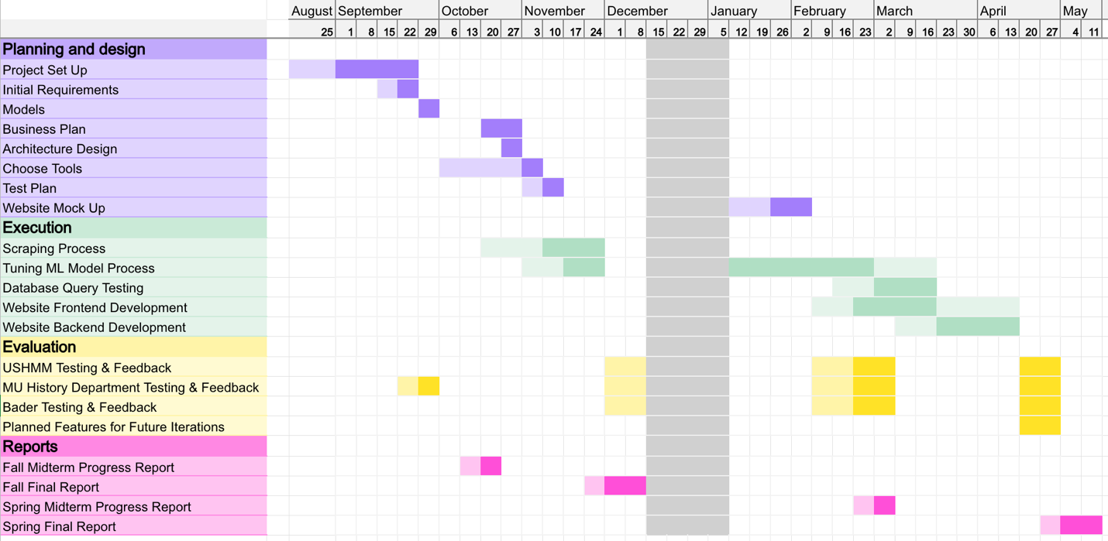
Team Balance
Team members are expected to work approximately 5 hours per week throughout the school year. We have agreed to keep our Trello board updated with our tasks. Monitoring the board will help us all keep track of the amount of work each member is putting in, whether anyone is falling behind, and if anyone needs help or is blocked on their tasks. Any issues regarding team balance, specifically about completing work on time, will be discussed during our team meetings. Depending on the cause for the delay and the importance of the task, actions include having another team member jump in to help with the task or requiring the original team member to complete it in a timely manner.
Software Development Method
We are planning to use the Agile software development method to guide our continuous development separated into sprints.
Software Languages
- Python – all team members are comfortable with Python
- React.js - some team members have experience with React.js
Source Code Repository
https://github.com/TaniaMishra/people_of_the_holocaust
Project Management Tool
https://trello.com/b/F5ACtO8N/the-people-of-the-holocaust-senior-design
Testing Methodology and Strategy
All testing will be documented in a spreadsheet in our team’s shared OneDrive folder.
Experiment with ML models | 1. Randomly select 5 articles  2. Manually identify and record key terms and relevant information  3. Run the Hugging Face model on the article text  4. Record the key terms identified by the model
ML model testing | 1. Split the dataset into 3 sets: training, testing, verification  2. Analyze the performance metrics (accuracy, precision, recall, F1) and confusion matrix of the training set vs the testing set
Software testing | 1. Randomly select 15 people  2. Manually identify their corresponding information  3. Query the database for each person  4. Compare the database results with the expected results

Project Risks
Potential Risk | Ideas for mitigation
Machine learning model not accurately parsing the article text | Work on hypertuning the model  Try out other ML models in Python
Incorrect classification of victim vs perpetrator | Discuss potential pivoting of the features for each person in the database with Bader Philanthropies – focusing on the person and locations rather than trying to classify them as a victim/perpetrator

Section 5: Legal
Patent Infringement and Filing
After querying the US Patent and Trademark Office’s patent public search for conflicting patents, we were unable to find anything that conflicted with our project idea. Though historical research is inherently immune to patents because of its factual history, methods of collecting and organizing that research are patentable, so it was still worth looking. It’s possible that we submit a patent application for our algorithms, but it will take some time and ironing out exact design specifications before we’re able to write one up.
License Agreement
Our license agreement will mimic that of EBSCO, a collection of electronic research databases and resources. Users are granted a nontransferable and non-exclusive right to access our tool’s information, but ownership resides completely with Bader Philanthropies. Liability and copyright clauses will be included to ensure the proper use of collected information by visitors.
Regulatory and xQuality System
Though research databases are normally subject to regulation through the Institutional Review Board (IRB), historical research is exempt from restrictions as long as it is factual and scholarly. Thus, this will not be a concern for our tool.

Section 6: Financial Justification
Development Cost
The development cost of our project is estimated at $24,000. Assuming that each developer on our team is salaried at $90K for a full-time role, the hourly rate would be approximately $40/hour. Each developer on our team puts in around 5 hours per week on this project. The project spans a total of 30 weeks (15 class weeks per semester). Thus, cost for each developer is $6000. Our team consists of 4 developers, so our total development cost can be estimated at $24,000.
Hourly rate = $90000/1yr * 1yr/52wk * 1wk/40hr = $43.27, rounded to $40
Cost per developer = 5hr/wk * $40/1hr * 30wk = $6000
Development Cost = $6000 * 4 developers = $24000
Financial Rollup
A common benchmark for a viable software product is generating approximately three times the total development cost. Based on our estimated development cost of $24,000, the project would need to generate approximately $72,000 in revenue to be a self-sustaining product. However, our database is intended to be a free educational resource, so we are not focused on a commercial, profit-based revenue model. Instead, we can estimate the value generated based institutional support.
We estimated that our tool can potentially reach 10,000 users annually (discussed in detail in section 2). We can conservatively assume the below adoption rates within this population, following a realistic early adoption curve of 2-5-10%. Most digital archives and classroom tools charge an annual $5-$20 per student license fee, so are utilizing a hypothetical license fee of $10 per user per year for these calculations. This results in a total of $17,000 in revenue over three years.
Year | % of Target Audience | Estimated # of Users | Hypothetical Fee per User | Estimated Revenue
1 | 2% | 200 | $10 | $2,000
2 | 5% | 500 | $10 | $5,000
3 | 10% | 1,000 | $10 | $10,000

We estimate that sustaining hosting, server maintenance, and minor updates would cost around $3,000 annually. We anticipate relying on philanthropic sponsorships or grant funding from our primary stakeholders: The Bader Foundation and The United States Holocaust Memorial Museum.
While not designed as a for-profit product, The People of the Holocaust Database has a plan for financial stability through institutional support. This project’s long-term value is based in its contribution to historical education and research, as well as digital preservation of the Holocaust time period.

